Cape Elizabeth Town Council Minutes
DRAFT Monday, August 8, 2016
7:00 p.m.
Cape Elizabeth Town Hall
Molly MacAuslan, Chair
James M. “Jamie” Garvin
Patricia K. Grennon
Caitlin R. Jordan
Sara W. Lennon
Katharine N. Ray
Jessica L. Sullivan

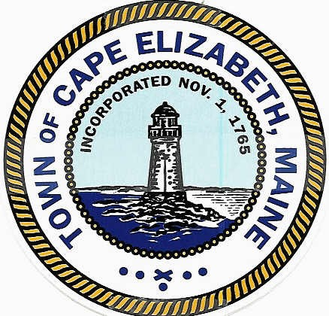

The meeting was called to order at 7:00 p.m. by Town Council Chair Molly MacAuslan.

Roll Call by the Town Clerk

All members of the town council were present except Katharine N. Ray.

Debra M. Lane, Town Clerk
Michael K. McGovern

Pledge of Allegiance to the Flag

Town Council Reports and Correspondence

Councilor Grennon announced the second of two council public forums. The citizen roundtable will be held on Monday, September 19 at 7:00 p.m. in the Middle School Cafetorium. The forum is to obtain citizens’ ideas on goals for next year.

Finance Committee Report

Mr. McGovern reported the audit for fiscal year end 6/30/2016 is nearly complete. Tax bills will be mailed next week.

Citizen Opportunity for Discussion of Items Not on the Agenda

David Weatherbie, 14 Stonegate Road, Former long-term president of the Beach to Beacon Road Race. Mr. Weatherbie said a recent article in the Portland Press, regarding charitable contributions, may have “blemished the reputation of the race.” He “reemphasized the purpose” of the race and stated although the bylaws do not include a requirement for charitable donations many charities do benefit. He also clarified payments/salaries to the race director and organizers.

Kate Wolf, 5 Crescent View Avenue asked why Shawn Tamir, the owner of 1 Crescent View Avenue isn’t being “fined or shut down for an illegal” rental property.

Town Manager’s Monthly Report

Mr. McGovern responded to Ms. Wolf’s question and said the code enforcement officer is aware of
1 Crescent View Avenue and working on it.

A full manager’s report is available online. See attachment.

Councilor Garvin reported on the recent forum sponsored by the Cape Elizabeth Garden Club regarding winter moths and the state’s mitigation program.

Page 2 Town Council Minutes
August 8, 2016

Review of Draft Minutes of July 11, 2016 meeting

Moved by Patricia K. Grennon and Seconded by Sara W. Lennon
ORDERED, the Cape Elizabeth Town Council approves the minutes of the meeting held on August 8, 2016 as written.
(6 yes) (0 no)

Item #101 -2016 Ocean House Pizza Annual License Renewals

Moved by James M. Garvin and Seconded by Sara W. Lennon
ORDERED, the Cape Elizabeth Town Council approves the annual renewal malt and vinous liquor license for Ocean House Pizza at 337 Ocean House Road as presented.
(6 yes) (0 no)

Item #102-2016 Paper Streets

Moved by Patricia K. Grennon and Seconded by Caitlin R. Jordan
ORDERED, the Cape Elizabeth Town Council sets a public hearing for Monday, September 12, 2016 at 7:00 p.m. regarding recommendations for extending, discontinuing or accepting the town’s incipient rights in certain paper streets.

Public comment

Chris Boulos, 60 Edgewood Road owns a lot on Stone Drive that abuts a paper street. He asked for consideration if the paper street is “let go” it will put the lot under 10,000 square feet.

(6 yes) (0 no)

Item #103-2016 Comprehensive Planning Committee

Moved by Sara W. Lennon and Seconded by Patricia K. Grennon
ORDERED, the Cape Elizabeth Town Council refers the draft charge of a comprehensive planning committee to an upcoming town council workshop in preparation for a comprehensive planning committee to begin meeting in early 2017.
(6 yes) (0 no)

Item #104 -2016 Affordable Housing Relief Request Update

Intro – Mr. McGovern

Moved by Jessica L. Sullivan and Seconded by Caitlin R. Jordan
ORDERED, the Cape Elizabeth Town Council approves the recommendation of the town manager to
waive the town’s right to purchase two affordable housing units at Eastman Meadows that have
remained unsold for some time. The two units could be sold to non-qualified buyers at market rates
with any excess over $409,451 for each unit to be provided to the town for other affordable housing.
(6 yes) (0 no)

Page 3 Town Council Minutes
August 8, 2016

Item #105-2016 Proposed Picnic Shelter Improvements

Intro – Mr. McGovern

Present – Tom Meyers, Rotary Club of South Portland-Cape Elizabeth

Moved by James M. Garvin and Seconded by Jessica L. Sullivan
ORDERED, the Cape Elizabeth Town Council approves the plans for updating landscaping leading to and around the picnic shelter at Fort Williams Park and accepts funding for the work to be provided by the Rotary Club of South Portland-Cape Elizabeth. The Town thanks the Rotary club for its continuing generosity.
(6 yes) (0 no)

Item #106-2016 Council Goals Relating to Potential New Revenues

Intro – Councilor Sullivan

Moved by James M. Garvin and Seconded by Patricia K. Grennon
ORDERED, the Cape Elizabeth Town Council refers the report on revenues to a future workshop meeting of the town council.
(6 yes) (0 no)

Item #107-2016 Collective Bargaining Agreement with Teamsters Local 340 Representing Public Works

Intro – Mr. McGovern

Moved by Jessica L. Sullivan and Seconded by Patricia K. Grennon
ORDERED, the Cape Elizabeth Town Council approves a two-year collective bargaining agreement,
effective July 1, 2016, with Local 340 of the Teamsters representing most public works employees as
presented.
(6 yes) (0 no)
See attachment.

Page 4 Town Council Minutes
August 8, 2016

Item #108-2016 Follow up on Action at Previous Meeting

Moved by Jessica L. Sullivan and Seconded by Sara W. Lennon
ORDERED, the Cape Elizabeth Town Council accepts the following which is to ensure there is no confusion regarding prior appointments and other administrative matters following the 7/11/2016 adoption of the new Chapter 4 Board and Committees Ordinance.

- All persons holding membership on the following committees shall maintain their current appointment status including expiration of terms of office on the successor committee. All term limits provided for membership and officers shall include time on both the original committee and the successor committee regardless of the change in name of the committee. Officers of committees shall continue in place in the same manner.
- The members and officers of Board of Trustees of the Thomas Memorial Library as constituted on August 8, 2016 shall continue in office as the Thomas Memorial Library Committee.
- The members and officers of the Board of Trustees of Riverside Memorial Cemetery as constituted on August 8, 2016 shall continue in office as the Riverside Cemetery Committee.
- The members and officers of the Conservation Commission as constituted on August 8, 2016 shall continue in office as the Conservation Committee.
- The members and officers of the Community Services Advisory as constituted on August 8, 2016 shall continue in office as the Community Services Committee.
- The members and officers of the Fort Williams Advisory Commission as constituted on August 8, 2016 shall continue in office as Fort Williams Committee.
- The members and officers of the Zoning Board of Appeals as constituted on August 8, 2016 shall continue in office as the Board of Zoning Appeals.
- All other committees and boards not named above but listed in Sec. 4-1-6 of the Boards and Committees Ordinance to be effective on August 12, 2016 shall continue as constituted on August 8, 2016.

- All by-laws and policies previously approved by the town council for boards, commissions and committees that have successor or continuing unchanged identical names for such boards and committees as identified in paragraph 1 a. thru f. shall remain in place for the successor or continuing board or committee and said by-laws are considered approved in conformance with Sec. 4-1-6 B.1. with references to any retired name in all by-laws, policies, hereby approved for substitution with the new name.

- As the various committees described above are each the continuation of the identified previously named board, committee or commission with new names, the tangible or intangible personal property including all accounts, all legal agreements, contracts, records and other property of the prior board, committee or commission shall constitute the legal agreement, contract, tangible or intangible personal property including all accounts, records or other property of the re-named committee.
Moved by Caitlin R. Jordan and Seconded by Sara W. Lennon
ORDERED, the Cape Elizabeth Town Council amends the motion as follows;
- All other committees and boards not named above but listed in Sec. 4-1-6 of the Boards and Committees Ordinance to be effective on August 12, 2016 shall continue as constituted on August 8, 2016. , except for the Firing Range Committee which shall be reconstituted.
(6 yes) (0 no)

Original Motion as Amended:
(6 yes) (0 no)
Page 5 Town Council Minutes
August 8, 2016

Item #109-2016 Potential Citizen Survey

Intro – Mr. McGovern

Moved by Jessica L. Sullivan and Seconded by Sara W. Lennon
ORDERED, the Cape Elizabeth Town Council refers a possible citizen survey to a future workshop meeting of the town council.
(6 yes) (0 no)

Citizens may at this point in the meeting raise any topic that is not on the agenda that pertains to Cape Elizabeth local government.
None

Adjournment

Moved by James M. Garvin and Seconded by Caitlin R. Jordan
ORDERED, the Cape Elizabeth Town Council adjourns at 8:01 p.m.
(6 yes) (0 no)

Respectfully Submitted,

_______________________
Debra M. Lane, Town Clerk

Attachment Town Manager’s Report
August 8, 2016
Pages 6 – 9

Town Manager’s Update
August 8, 2016

The following items are of note since the last council meeting:

Stella B. Patten
Stella Patten passed away in Topsham on July 11, 2016. Stella served on the town council from 1975 to 1978. She was the first woman elected to the town council. The time she served was very busy for the town with closure of the open burning dump, a new alliance with what has become ecomaine, decisions to convert Fort Williams into an area that is predominantly a park, with the development of a large sewer project in the northern area of town and an agreement with South Portland to treat sewerage from the northern part of town. Stella was a strong advocate of citizen communication and published her own newsletter that was quite controversial at the time. Stella had also taught in both South Portland and Cape Elizabeth schools. I was happy to have been able to see her about a year ago when she was reminiscing about her time in Cape Elizabeth.

Beach to Beacon
The 19th annual Beach to Beacon Road race was this past Saturday with 6338 finishers including 639 registering with Cape Elizabeth addresses. Thank you to our municipal departments, the school department and all the volunteers who supported the event. We also could not have this event in Cape Elizabeth without all of the support we receive from neighboring communities. 

Road and Sidewalk Work
This past month Spurwink Avenue near the South Portland line and Wells Road were paved. A sidewalk was also substantially reconstructed on a portion of Oakhurst. Work will continue on another section of the sidewalk on Oakhurst Road.
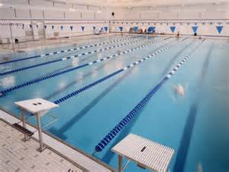
Pool Closed
The Donald Richards Community Pool closed on August 5th and is anticipated to be closed for 6 to 7 weeks while the pool filtering system is replaced and other repairs and updates are undertaken.
The work is being funded by a bond approved by the town council and work on doorway and shower facilities with an appropriation also approved by the town council.

Winter Moth Forum

The Cape Elizabeth Garden Club sponsored a forum last week at the Thomas Memorial Library on winter moths. Winter moths have defoliated many crabapple, red maple and oak trees in Cape Elizabeth. There is also an impact of blueberry shrubs. According to Charlene Donahue who is the state entomologist, three to four years of defoliation will result in tree mortality. She and Town Tree Warden Mike Duddy told the over 60 citizens who were present that broad based use of pesticides to combat the infestation is not possible as the secondary impacts would be significant. Some limited use of pesticides can help individual trees. Banding trees is also not practicable as the caterpillars would simply cover the bands quickly and continue up the trees. A placement of flies that attack the caterpillars is helpful but the supply of the flies is not significant enough to control the damage. This year this was less defoliation than a year ago due to the cold spring but the winter moths have spread over more of the community. The bottom line appears that we will have many trees needing to be removed in the next few years. In places like Fort Williams, outer Fowler Road, Charles Jordan Road, Shore Road, Mitchell Road and Old Ocean House Road, the appearance of the roads will change significantly as the tree canopy disappears. The town has already changed what trees in recommends to be planted in new subdivisions. The council may also wish to consider a larger budget for tree planting.

Upcoming Forums and Events from Town Website

Committee to hold public forum on amphitheater seating proposal for Fort Williams Park
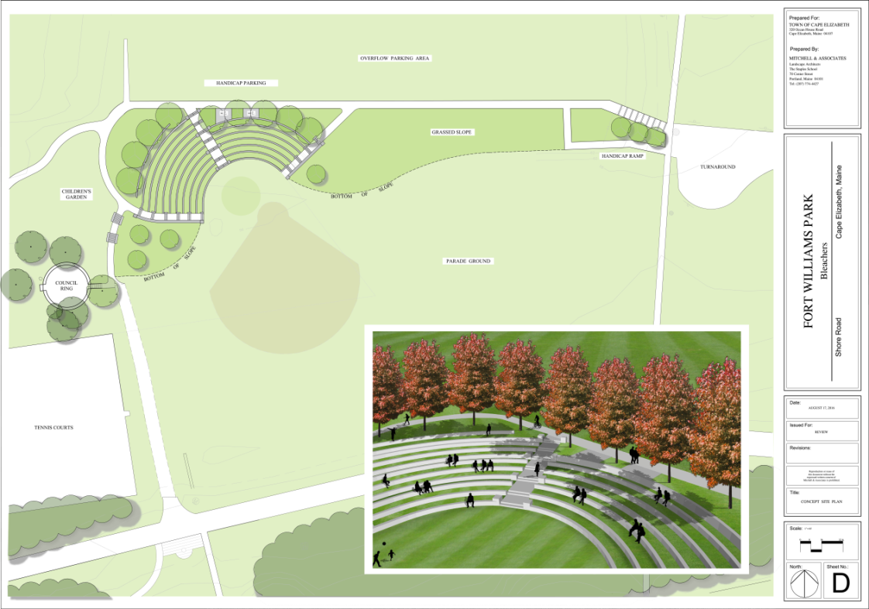Concept plan for amphitheater seating at the Fort Williams Park parade ground. The Fort Williams Park Committee will host a forum on the proposal Wednesday, Aug. 17, 2016 at Town Hall(click for larger image - image courtesy Mitchell & Associates)
The Fort Williams Park Committee will hold a public forum on a concept plan for proposed amphitheater seating at the park's parade ground.
The forum is scheduled for 7 p.m. Wednesday, Aug. 17, 2016, at Town Hall.
The park's budget for 2017 includes $440,000 for engineering and design of amphitheater seating constructed of grass and granite for 350 people. The seats would form a semicircle around the existing ballfield, replacing the concrete bleachers that were removed earlier this spring. [news article]
The funding is based on construction estimates provided by Mitchell & Associates, landscape architects. "It includes consulting services to see the project through Planning Board approval process (if approved by the Town Council) and construction," Public Works Director Robert Malley said. "It does not include ledge removal, a short water line extension and a handicap access ramp. Additional funding may needed for those items," he said.
The parade ground bleacher area has been a primary committee focus for the last two years and is among capital fund priorities. "The proposed amphitheater will provide a unique outdoor space for community gatherings, theatrical and musical performances and school graduations," committee Chairman Mark Russell said in a memo to the Town Council dated April 29, 2016, prior to the council's vote for 2017 budget approval. Some of the granite can be salvaged from Ship Cove, Russell said. The design of the amphitheater seating creates an inviting gateway to the children's garden under construction as part of the Fort Williams Park Foundation arboretum, the memo says.

Forum to gather feedback on pool, fitness center
The Community Services Committee wants your input on the pool and fitness center.
The committee will hold a public forum beginning at 6:30 p.m. Thursday, Aug. 25, 2016 in the High School cafeteria.
Part of the duties of the seven-member committee is to reach out regularly to assess satisfaction with current Community Services programming and to identify unmet needs. Please some share your ideas.
For more information please contact Russell Packett, Community Services director, 207-799-2868

Portland Head Light launches new website

New Portland Head Light and Fort Williams Park website
Portland Head Light has a new website.
The updated, mobile-friendly website for visitors to the lighthouse and surrounding Fort Williams Park was launched July 9, 2016. If features an interactive slide show of photographs, detailed information about the many popular attractions in the park, and secure forms for visitors to ask questions or provide feedback, or to reserve space for a wedding or other event at the park. Tour companies can also request a seasonal parking permit directly from the website.
"There was a need to modernize the Portland Head Light website, so with that thought in mind, it was decided to combine the Portland Head Light and Fort Williams Park into one new site," said Jeanne Gross, director of the Museum at Portland Head Light. The new site also includes information about the new arboretum, and children's garden currently under construction.
Gross, who probably fields more questions from potential park visitors than anyone, said she especially likes the clean, modern, intuitive design of the new website. "We asked photographers to donate the use of their photos and they provided great pictures," she added. Historical background on Fort Williams was provided by Ken Thompson.

New logo for Portland Head Light and Fort Williams Park website
Visitors planning a trip to Portland Head Light and Fort Williams Park will find on the website answers to some of the most common questions, such as:
- How much does it cost? (The citizens of Cape Elizabeth have decided to keep the park free for all to enjoy.)
- Is the lighthouse tower open to the public? (The tower is not open to the public.)
- Where are the trash barrels? (The park is a carry-in, carry-out facility.)
Slickfish Studios of Portland worked for four months on the design, incorporating new photographs and a new logo that reflects the dual nature of the website. "We designed the logo first, which took about a month, and then spent a considerable amount of time researching photography," said Slickfish owner and lead creative Gordon Holman. Slickfish also designed the site for the Fort Williams Park Foundation.
The work involved some patience, as the gloomy spring of 2016 did not portray the park in its best light, Holman said. "I even went a couple of times to take some pics for use on the site," he said.
The popular webcam photo, providing an updated view of Casco Bay from the lighthouse museum, is accessible from the "About Us" section.

Attachment Item #107-2016 Public Works Contract

